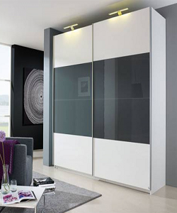

Sliding Door Wardrobe

$228.75

Availability: In stock

Description

Black and white modern glass wardrobe with 2 sliding doors. The structure of index wardrobe is made of glass and Plastic which is subsequently lacquered with special paints. The doors are made with full extension slides. The tubular base is adjustable and equipped with feet.